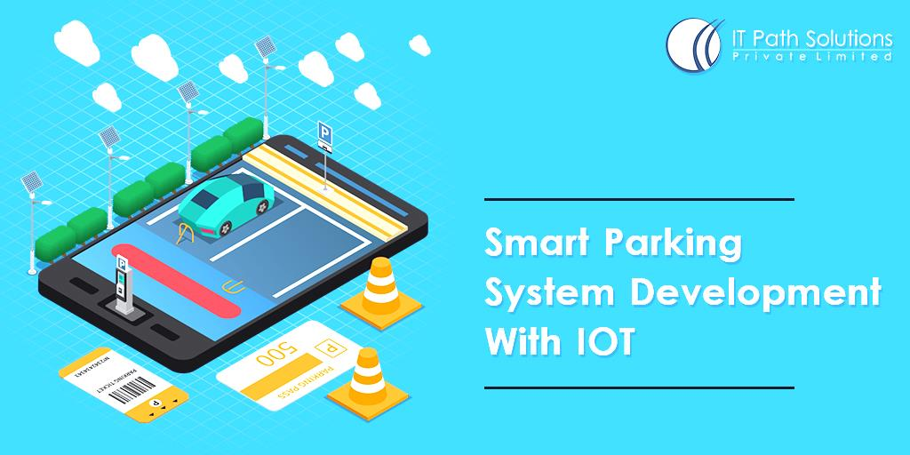

**Smart parking**  is a technological approach to improve the parking process and the cars’ positioning in a city with a shortage of space.

The basic goals of smart parking systems:

* to unload city roads from a growing number of vehicles,
* to reduce oil use and its negative impact on the atmosphere when drivers look for a parking lot, and
* to save the time and patience of city drivers who want to leave their cars closer to the destination point.

Any smart parking initiative implies the use of additional smart devices starting from a regular smartphone to special sensors and cameras in the parking areas. Also, AI takes its place among smart parking solutions. In other words, smart parking is a highly diverse branch using the latest tech advancements.

**BENEFITS OF SMART PARKING**

* **Faster parking.** The search for an empty parking space can be reduced significantly. Smart parking sensors allow for the finding a parking spot in the area in half the time, and they monitor the city and its traffic real-time, which provides the most accurate information.
* T**he higher level of safety and control for drivers and local authorities.** On the one hand, individual drivers are notified if they are in a no-parking area. On the other hand, traffic authority organizations are able to monitor parking violations as the sensors can be placed in different city areas. They will help to define where exactly parking violations happen most often and at what time they occur, and this data can also be delivered in real-time.
* **Space optimization in tight areas.** This point is helpful for business owners as well. While drivers save their time finding empty parking spaces, local businesses can use the space around their building to the maximum number of customers. For example, we all know that parking lots and spaces are not overloaded all the time. Smart city parking solutions assess regional rush hours and adjust fees for parking accordingly. And of course, smooth parking provides a positive experience for potential customers, which affects the overall impression of the visit.
* **More accurate traffic predictions.** And finally, real-time data gathered by smart parking apps day by day is an effective instrument to build seasonal trends and predictions. In other words, the city authorities will be able to see how the traffic changes throughout the year and what causes traffic jams – this information is a foundation for parking optimization.
* **Reduced emissions.** Even though we have already mentioned it, we would like to emphasize the global impact of smart parking on urban pollution. For some, finding a place to park in a mall’s parking lot or somewhere on the street is a minor issue, but for many it can be challenging and time consuming. Modern parking tools provide the means to streamline the parking process, and thus avoid the issue of wasted oil.

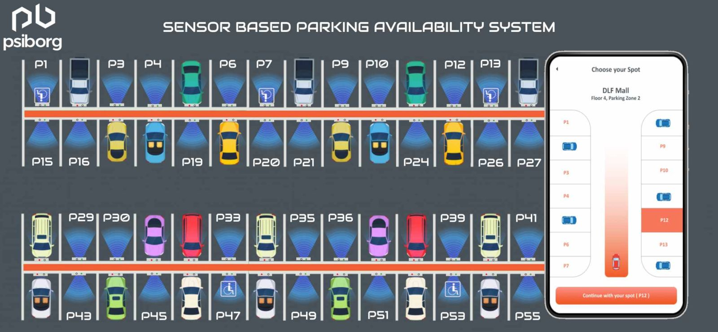 **How Smart Parking Works: Software and Hardware Tools**

More and more smart parking solutions are appearing on the market every day. We will review the most popular one – an IoT smart parking sensor.



**From the sensor’s side**

1. The smart parking sensor is positioned in a p vcarking space, underground. Before the work starts, the sensor should be properly calibrated.
2. The vehicle located in a parking space changes the earth’s magnetic field, and the sensor tracks this change.
3. The occupation status is then sent to the central server.

**From the user’s side**

1. Users can track the sensors’ signals in real-time from a PC or smartphone. First and foremost, drivers see all parking areas around them along with free spots they can take – it looks like an interactive map. The interface of such a tool is usually simple and user-friendly. Quick navigation is essential when driving: no extra taps on the smartphone screen – only minimalistic and understandable navigation symbols (big icons, vivid arrows, etc.).
2. Smart cities parking usually involves third-party integrations. For instance, an app developed for a certain company should be easily integrated with the devices of the city’s authorities. So, software development includes building an API in this case.

**Ways to use smart parking technologies**

Smart parking tools are not limited to parking sensors. The branch is constantly growing and developing, and smart sensors have become one solution among a huge variety of others. These are the most interesting examples.

**1. Counter systems**

The counter system is another smart device that detects when a car appears in the parking lot and when it leaves. This data is then processed by the IoT device, and it can identify free parking spots at any given moment.

The data from the counters is stored in the cloud, so parking managers can use it later for analysis and demand predictions.

### ****2. Control systems****

Control systems have several features that make them more complex than sensors or counter systems. A control system detects if someone breaks parking rules, then it registers the violation and stores the evidence (a photo or a video), plus, it can issue a ticket and inform the violator.

This way, smart parking solutions exclude the human component and contribute a lot to reducing the city’s expenses and increasing safety as they often have to work tirelessly

### ****3. Lifts****

Parking lifts are aimed to optimize parking spaces by increasing the capacity of the parking lot. Lifts help optimize even the tiniest spaces by exploiting vertical space, allowing the placement of up to three cars on the same parking spot.

### ****4. Valet robots****

No, this is not a plot of some futuristic movie – AI is now used to simplify the parking process. Parking robots serve as valets that take your car and place it with maximum efficiency.

Robotic car parking is complex and involves several components. It works similarly to AI robots but involves lifts, shelves, and other similar tools. In other words, this is a robotic system that simplifies and organizes the parking process.

### ****5. Flexible parking fees****

**The pollution level.** High pollution is an enormous challenge for lots of big cities, so authorities opt for modern technologies to encourage people to drive “greener” cars. Pollution-based fees is another way smart parking technology helps us to take care of the planet.

System checks the car’s year and engine, then calculates parking fees based on this information. As a result, the owners of hybrid and diesel vehicles pay a 20% lower price, while for electric cars it is completely free. This should encourage citizens to drive eco-friendly cars in the city area.

**The car’s length.** Do you prefer bigger cars? You should be ready to pay more for their parking. This is a democratic way to support the owners of smaller cars, whose vehicles take less space. In other words, you pay not only for the time but also for the space occupied. And, of course, smaller cars are another eco-friendly option.

## 6.3D parking design and signalling

3D design and signaling are shaping the use of innovative technologies like parking aid. The technology, offered by Bosch, uses sensors integrated into the vehicle’s bumper to sense and signal course adjustments and obstacles to the driver.

It does this either with a high-pitched sound that increases in pitch as the vehicle nears obstacles, or by use of a 3D model of the vehicle’s environment. This ensures access to inch-perfect parking in situations where every inch counts.

In 2020, we can look forward to the technology, which is already included in several modern car and sports vehicle designs, being integrated with other parking solutions.

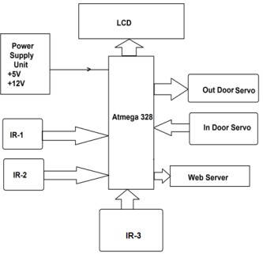

## 7. Wireless charging on parking spots

If you already own an electric vehicle, you’ll be excited about this one. Nobody likes dealing with unending coils of cables, and we’re sure electric car owners are no different.

With recent innovations in wireless charging, you can finally say goodbye to cords for good. Several wireless charging solutions were already available in 2019, and with vendors like [Plugless](https://www.pluglesspower.com/learn/ev-charging-logistical-pains-go-wireless/), you can even enjoy wireless charging at your favorite parking spots or while on the go.

The charging solutions, usually referred to as wireless level 2 charging, utilize 240-volt outlets that can be placed anywhere. The outlet is connected to a charging pad that sits beneath the vehicle and once in place, the vehicle charges itself. With the increasing rise in purchase of electric vehicles, wireless charging will only get more popular.

## Smart Parking sensors

The superstar of parking innovation, smart parking sensors are disrupting parking in modern cities across the world. They implement Internet of Things capabilities to provide real-time, almost boundless smart parking and traffic advantages.

These sensors are directly responsible for significantly cutting down on the time that drivers spend searching for parking spots. The sensors communicate in real time with a Parking-Routing-Information-System (PRIS) to guide drivers to available parking spaces.

For instance, [Parkeagle’s sensors](https://parkeagle.com/streeteagle-product/) are capable of counting the vehicles at a large parking facility and determining which parking spaces are available. It then communicates this information to the [ParkSmart app](https://www.parkeagle.com/our-technology) in real-time. With this innovation, it is now possible to adequately manage parking-caused congestion and reduce overall emissions.

## ****Parking and a smart city****

IoT systems for smart parking is a constantly evolving trend. Starting from underground sensors to AI robots – drivers get a variety of options. We may expect this trend to grow because it also provides benefits to business owners, city authorities, and finally, the environmental situation in the area.

Saved time, less dense traffic, more effective parking space usage – this is not the full list of smart parking advantages. IoT innovations are here to help improve any city’s infrastructure.